“Київський фаховий коледж зв’язку”

Циклова комісія Комп’ютерної інженерії

**ЗВІТ ПО ВИКОНАННЮ**

**WORK-CASE №4**

з дисципліни: «Операційні системи»

Виконавли студенти

групи РПЗ-03

Команда: Губенко Є.О.,

Заїка С.В. та Кресан Р.А.

Перевірив викладач

Сушанова В.С.

Київ 2022

**Хід роботи**

***Готував матеріал студент: Заїка С.В.***

1. **В ході роботи досить часто виникає необхідність встановлювати нові програми та додатки. Для цього необхідно в терміналі вміти працювати з менеджерами пакетів:**

* **Дайте розгорнуте визначення таким поняттям як «пакет» та «репозиторій».**

*A package is a file that contains software components, such as program libraries, executables, settings, etc., that are required to install and operate a particular software product. A package can be a program distribution or a configuration file that contains information on how to install and configure the program. Package management systems allow users to quickly and easily install and update programs on their computer by unpacking and configuring packages using automated tools.*

*A repository is a collection of packages stored on a remote server and contained in a directory that can be accessed via the Internet. Repositories contain information about packages, including versions, dependencies, and other details. Users can use package management systems to search for, install, and update packages from the repository. Repositories can be created by different organizations and software developers, allowing users to quickly and easily access new versions of software, including security and other updates*

* **Надайте короткий огляд існуючих менеджерів пакетів у Linux. Охарактеризуйте їх основні можливості.**

*Linux has several package managers that allow users to install and update software packages quickly and easily. The main package managers in Linux include*

*- Advanced Packaging Tool (APT): This is a package manager used in Ubuntu, Debian, and their derivatives. APT allows users to install and update packages using a user-friendly command line interface.*

*- Yellowdog Updater Modified (YUM): This is a package manager used in Fedora, CentOS, and Red Hat Enterprise Linux. YUM allows users to install and update packages using a command line and graphical user interface.*

*- Pacman: is a package manager used in Arch Linux and its derivatives. Pacman allows you to install and update packages from the command line.*

*- Zypper: This is a package manager used in openSUSE and its derivatives. Zypper allows users to install and update packages from the command line and graphical user interface.*

*The main features of these package managers include:*

*- Installing, updating, and uninstalling packages from the command line and/or GUI.*

*- Dependencies: automatically installs the necessary dependencies for installed packages.*

*- Search and view information about packages available in the repository.*

*- Ability to add your own repositories and customize the package manager.*

*- Advanced configuration and customization options.*

*- Security: Most package managers allow users to digitally sign packages, which provides protection against malware and viruses.*

*- Ability to create and manage custom packages: This allows users to create their own packages of software and other components and install them on their systems*

***Готував матеріал студент: Губенко Є.О.***

1. **Визначте який менеджер пакетів використовує ваш дистрибутив Linux. Опишіть основні команди для роботи з ним:**

* **Пошук, скачування та установка необхідних пакетів, яких у Вашій системі немає (зі сховища по замовчуванню, з нового репозиторію тощо).**

To find, download, and install the necessary packages in Linux, you can use various tools, such as APT (Advanced Package Tool) for Debian and its derivatives (Ubuntu, Linux Mint, etc.), DNF (Dandified Yum) for Fedora and other distributions that use RPM packages, and pacman for Arch Linux.

Search for packages:

To search for packages, run the command in the terminal, replacing the word package_name with the name of the package you are looking for:

For Debian/Ubuntu/Linux Mint:

sudo apt search package_name

For Fedora:

sudo dnf search package_name

For Arch Linux:

pacman -Ss package_name

Download and install packages:

Once you have found the package you want, you can download and install it with the following commands:

For Debian/Ubuntu/Linux Mint:

sudo apt install package_name

For Fedora:

sudo dnf install package_name

For Arch Linux:

sudo pacman -S package_name

If the package is not found in the default repository, you can add a new repository to your system and install the package from there. For example, to add a repository on Debian/Ubuntu/Linux Mint, run the following command:

sudo add-apt-repository repository_url

Instead of repository_url, specify the URL of the repository. Then update the package list and install the package with apt:

sudo apt update

sudo apt install package_name

For Fedora, use the dnf command to add the repository and install the packages:

sudo dnf config-manager --add-repo=repository_url

sudo dnf install package_name

For Arch Linux, you can add a new repository to /etc/pacman.conf and update the package database by running the following command

sudo pacman -Sy

Then install the package as usual:

sudo pacman -S package_name

If you can't find the package in the standard repositories, you can search for it in other sources, such as PPA for Ubuntu, COPR for Fedora, or AUR for Arch Linux.

Adding a PPA for Ubuntu:

A PPA (Personal Package Archive) is a repository of packages that are created by Ubuntu users and hosted on the Launchpad. To add a PPA to your system, run the following command:

sudo add-apt-repository ppa:PPA_name/ppa

Instead of PPA_name, specify the name of the PPA. After that, update the package list and install the package with apt.

Adding COPR for Fedora:

COPR (Cool Other Package Repository) is a service that allows Fedora users to host their own packages. To add COPR to your system, run the following command:

sudo dnf copr enable username/repo

Instead of username/repo, specify a username and the name of the repository. After that, update the package list and install the package using dnf.

Adding an AUR for Arch Linux:

The AUR (Arch User Repository) is a repository where users can host packages for Arch Linux. To install a package from AUR, you must first install an AUR helper, such as yay or aurman. Then run the following command:

yay -S package_name

Instead of package_name, specify the name of the package from AUR. Yay will automatically download the package information, build it, and install it.

This way, you can add repositories and install packages as you need them. Pay attention to the source of the package before installing it and make sure it is reliable and trusted

* **Перегляд інформації про встановлені та доступні пакети.**

*To view information about installed packages, use the dpkg command in Ubuntu or rpm in Fedora:*

*On Ubuntu:*

*dpkg -l*

*This command displays a complete list of installed packages with status, version, and a brief description.*

*In Fedora:*

*rpm -qa*

*This command displays a list of installed package names.*

*To view information about available packages that can be installed, use the apt command in Ubuntu or dnf in Fedora:*

*On Ubuntu:*

*sudo apt-cache search package_name*

*This command will return a list of all packages that contain the word "package_name" in the name or description.*

*On Fedora:*

*sudo dnf search package_name*

*This command will return a list of all packages that contain the word "package_name" in their name or description.*

*To get detailed information about a package, use the apt or dnf command with the show option:*

*On Ubuntu:*

*sudo apt show package_name*

*This command will return full information about the package, including description, version, dependencies, and repository.*

*In Fedora:*

*sudo dnf info package_name****.***

* **Видалення непотрібних або застарілих пакетів.**

*To remove unnecessary or outdated packages, use the apt command in Ubuntu or dnf in Fedora:*

*In Ubuntu:*

*sudo apt autoremove*

*This command will remove all packages that were installed as dependencies but are no longer used on the system.*

*In Fedora:*

*sudo dnf autoremove*

*This command will remove all packages that were installed as dependencies but are no longer used on the system.*

*If you want to remove a specific package, use the apt or dnf command with the remove option:*

*On Ubuntu:*

*sudo apt remove package_name*

*This command will remove the package with all dependencies that were installed with it.*

*In Fedora:*

*sudo dnf remove package_name*

*This command will remove the package with all dependencies that were installed with it.*

*If you want to remove the package but keep its configuration files, use the --purge option:*

*On Ubuntu:*

*sudo apt remove --purge package_name*

*In Fedora:*

*sudo dnf remove --noautoremove package_name*

*Please note that some commands may require administrator (sudo) privileges.*

* **Оновлення менеджера пакетів.**

*To update the package manager, follow these steps:*

*On Ubuntu:*

*sudo apt update && sudo apt upgrade*

*This command updates the package lists of the remote repository and installs updates that are available for the installed packages.*

*On Fedora:*

*sudo dnf upgrade*

*This command updates the installed packages to the latest version.*

*After running these commands, the package manager will be updated to the latest version, if available. The packages that were installed on the system will also be updated. Note that some commands may require administrator privileges (sudo).*

***Готував матеріал студент: Кресан Р.А.***

1. **Встановіть у терміналі через менеджер пакетів на свою систему:**

* **Новий відео- чи аудіоплейер.**

*Through the terminal of my system, I installed a new video player. I chose VLC because it is the most popular video player.*

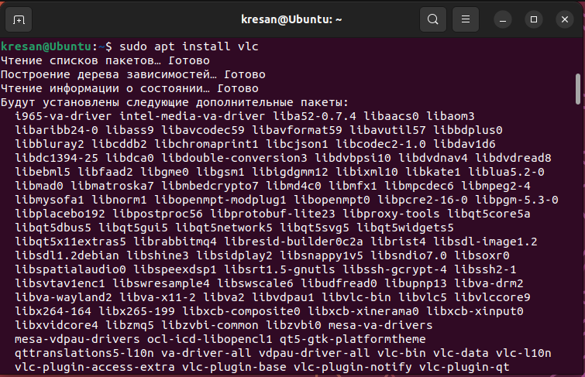

*Once the download is complete, we can run it through the terminal or application menu.*

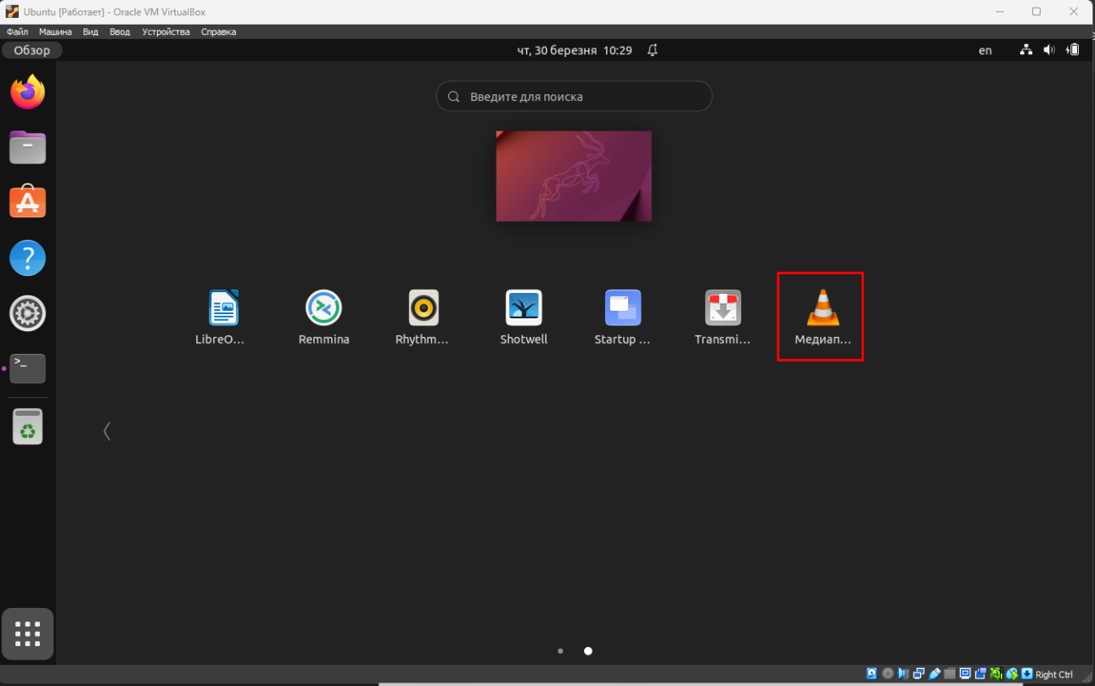

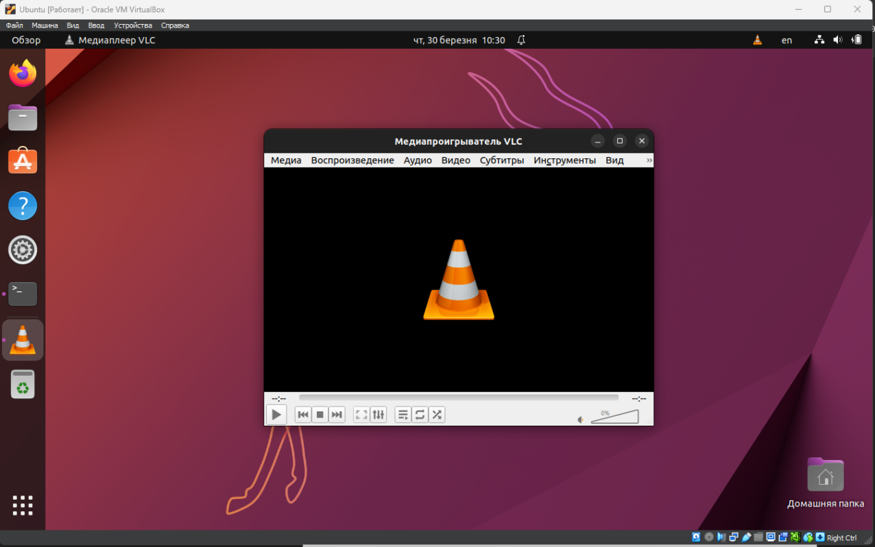

* **Середовище для мови програмування, що ви вивчаєте.**

*I chose SASM (the Assembler programming language environment) as my programming language environment. You could also install Visual Studio, but it takes up a lot of space.*

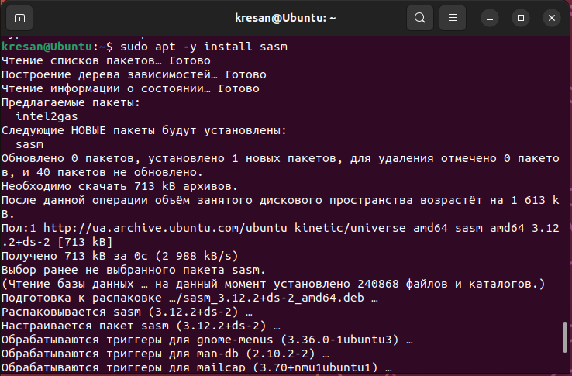

*After the installation process is complete, the program can be launched from the application menu.*

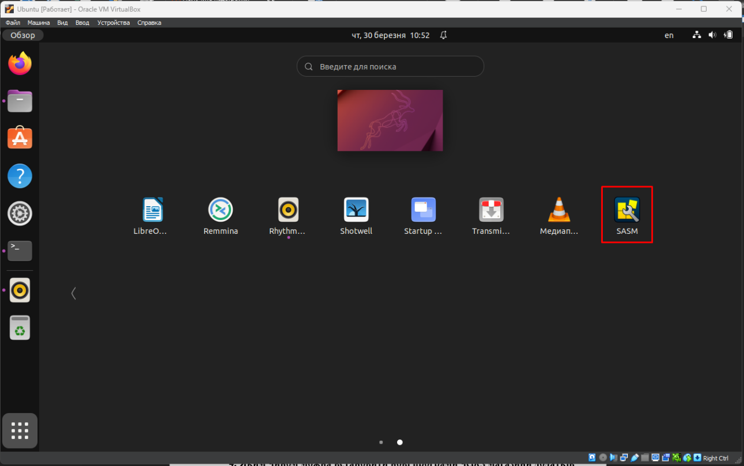

*After the program has opened, you can try to write commands, but for correct operation, you need to insert additional files.*

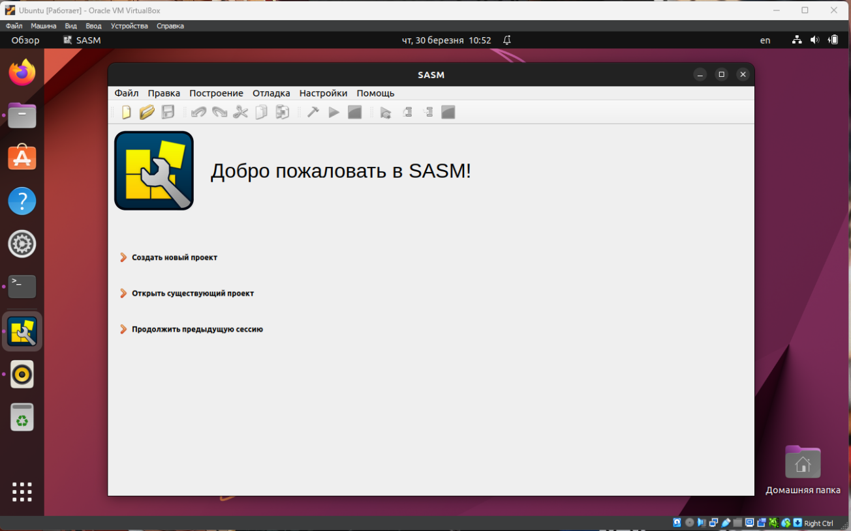

***Готував матеріал студент: Кресан Р.А.***

1. **Яким чином можна встановити нові програми через магазини додатків та менеджери пакетів у графічному середовищі. Наведіть свої приклади.**

*To install a new program through the app store, you need to open Ubuntu Software.*

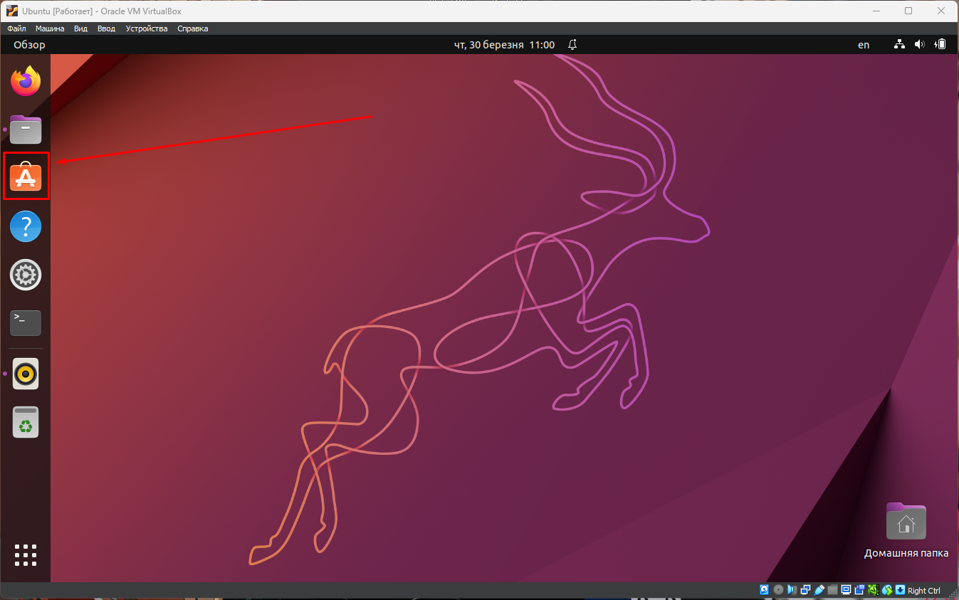

*You can use the recommendations or the search button to select the application you need.*

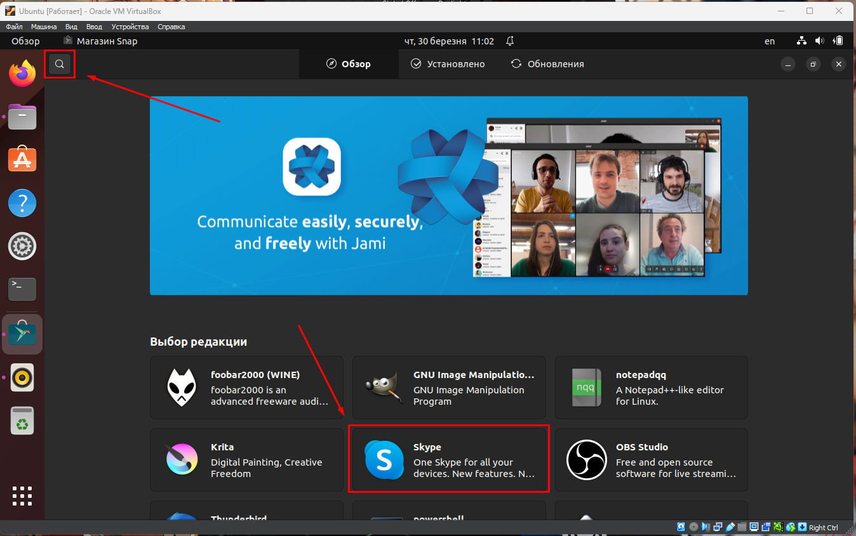

*When we have selected the required application, we click the "Install”.*

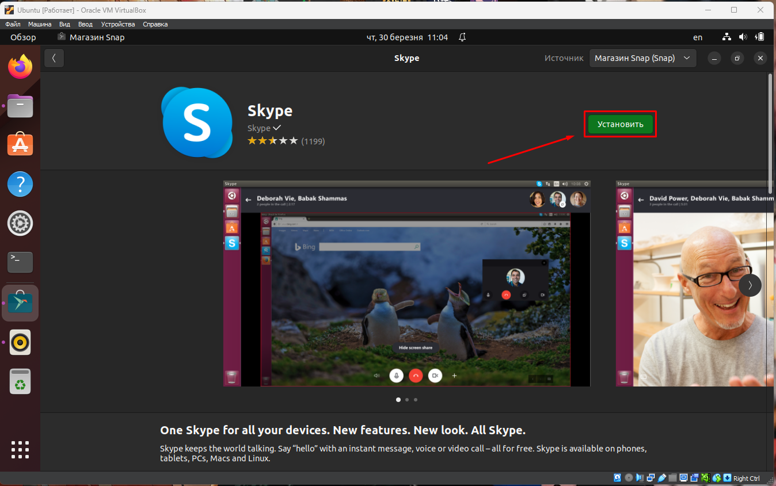

*After the installation process is complete, our program will appear in the application menu.*

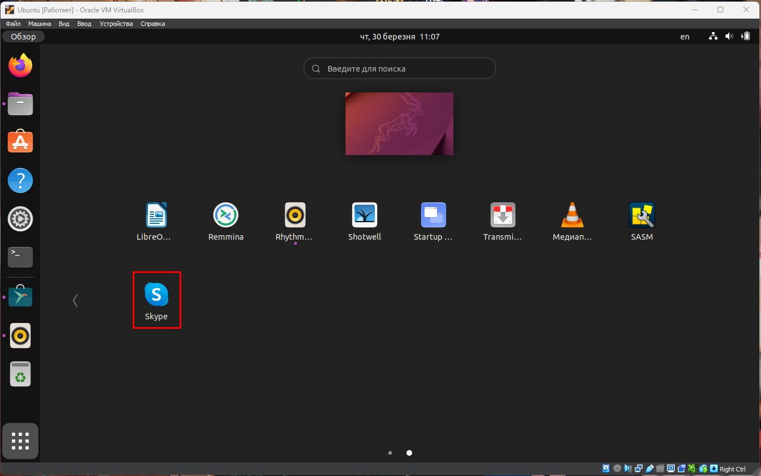

*If the program is not available in the app store, we can install it using the package manager. To do this, open a terminal and run the command sudo apt install program_name, where "program_name" is the name of the program we want to install. After we run the command, the package manager will update the list of packages and install the program. After the installation is complete, we can find the program in the application menu or run it from the terminal.*